Analysis of Jets and Flow in Hadronic Collisions for Differing Quantities of Dijet Pairs

Dylan Packard

With Dr. George Moschelli and Dr. Sean Gavin

**1 Intro**

Over the period of the past summer, I’ve been working on determining the significance of multiple observables and how they differ between quantities of dijet pairs existent in the corresponding collision and aftermath. Throughout the research, I was looking to determine the quantity named *D*  and see how the quantity changed when looking exclusively at n-pairs of dijets. Throughout the process, I created a macro utilizing ROOT to analyze the data which was generated by PYTHIA and FastJet, which I will explain further on in this introduction.

More specifically, I was observing proton-proton collisions at identical energies to those utilized during the 2013 LHC experiments (7 TeV).

**1.1 Flow/Jets and Generation of Particles**

To begin with, it is necessary to define exactly what “flow” is and what we consider a jet. Flow, also known as anisotropic or thermal expansion, is a fluid like expulsion of energy from a collision of two particles (be it protons or otherwise) which expands outward laterally with a certain transverse momentum arising from this fluid expansion.

Jets, on the other hand, are high energy particles which are ejected violently from the collision of two particles. The high energy resulting from the collision of two high-momentum particles results in the creation of particles from the collision, which are then expelled in multiple jets of high-momentum particles. These jets are formed in pairs conservatively, with equal energies in either direction, resulting in what are referred to as dijets, or dijet pairs. In this case, the transverse momentum of the system is contained in the particles being expelled from the collision. This generation of transverse momentum is very important to the research which I have been conducting, as the generation of particles in a collision is tied to this transverse momentum transfer.

**1.2 PYTHIA, FastJet and ROOT**

To begin the process, we utilize PYTHIA to generate events at a certain total energy level (in this case, 7 TeV) with a variable minimum on the transverse momentum per particle accepted by the engine. Higher minimums would result in fewer low energy particles being accepted into the pool of accepted particles and would positively impact the total transverse momentum for the system. In this way, it was possible to observe only the higher-energy particles in a collision without the added noise of low-energy particles coloring the results. This process enabled us to look more exclusively at higher quantities of dijet pairs with less and less noise as the minimum was raised.

The resulting data is stored in a ROOT file, with information per event and per particle being stored in separate class structures. This data is then taken into FastJet, which will group particles into jets so long as they apply to certain criteria which is provided to the engine. In this case, FastJet was supplied with seven restrictions on what is a jet for our research:

1. All particles in the jet must have greater than 1 GeV transverse momentum
2. All clusters must have greater than 5 GeV total transverse momentum
3. The anti-KT clustering algorithm is used to determine which particles make it to the next stage (utilizing R = 0.4)
4. The leading jet of the pair must have greater than 10 GeV total transverse momentum
5. The sub-leading jet of the pair must have greater than 5 GeV total transverse momentum
6. Dijet pairs must be “back-to-back,” where the difference in the angles is within the tolerance set by R (Δφ – π < 0.4)
7. The jet candidates (those that pass the previous six steps) are ordered in terms of greatest magnitude. The jet on the top of the list is then paired with the next highest momentum jet until the list is depleted and all jets have been paired.

This information is then stored again into a ROOT file with same procedure as the data coming from PYTHIA. This ROOT file is opened by the macro which I helped design this summer. The macro loops through the entirety of the data and calculates various totals, observables, and histograms. Each step towards calculating *D* is recorded via independent observables and through histograms, allowing us to compare to determine existence of bias and errors in the histograms.

However, due to rather large margins of error utilizing the original code, it was deemed fit to replace with a new form of the analysis code which would calculate the larger averages utilizing a method which would prevent buffer-overflow errors from occurring. This is what was used for the final verdict on *D*.

**2 *D*, Observables and Correlation**

The entirety of my research hinged on the calculation of observables to determine what was occurring in the aftermath of high-energy collisions of two protons, and using those observables as an indicator for other collisions as to what had occurred after the collision (jets/flow). The first step in this process was to calculate the average transverse momentum per particle ($<p_{T}>$) as a function of multiplicity. This served a two-fold purpose, as it would serve as a sanity check for the code (by referring to a similar chart from the ATLAS experiment) and also as a basis for the calculation of *D*  farther down the line. Following this was a series of histogram/independent calculations of the various components of *D*  such as the total average transverse momentum ($<P_{T}>$), the total average number of particles per event ($<N>$). To calculate *D*  we used the following equation:

$$\text{D}\text{ = }\frac{1}{<N^{2}>}[<P_{T}N> - <P_{T}><N> - <p_{T}>\left(<N^{2}> - {<N>}^{2}\right)]$$

As shown above, the calculation of *D*  the covariance between the total average momenta of the event and the number of particles present in the event, and the variance of the total number of particles present in the event multiplied by the average transverse momentum of individual particles.

The main proposition underlying *D* is the differentiation between the jets and flow discussed above. *D*  will behave differently dependent on the source of transverse momentum for the collision following the impact. Take for instance the case of flow, where transverse momentum comes from the anisotropic expansion of the collided particles. In this case, each individual particle will have a similar momentum to each other particle involved in the collision, forcing the covariance and variance to approach equal values, and thus driving *D*  towards zero.

The other case which we accept with *D*  is the presence of jets resulting from the collision. In this case, there are high energy (and thus high momentum) particles ejected from the impact. Due to these higher energies, there are also fewer particles overall created from the impact (as per conservation). As such, covariance between the average momentum per event and the average number of particles per event will increase dramatically, while the variance of the number of particles per event will have less of an impact and thus become technically negligible.

**3 Results and Analysis**

Using runs of 5 million events total with a beam energy of 7 TeV we discovered that for the case of the total event (not looking at individual classes of jets) *D*  held up to expectations. The covariance was larger as we were expecting, and holds for all instances of the calculation for no jet classes.

In addition to this, the plot of $<p_{T}>$ vs multiplicity also conformed to expectations set by the ATLAS 2011 project, as shown below:

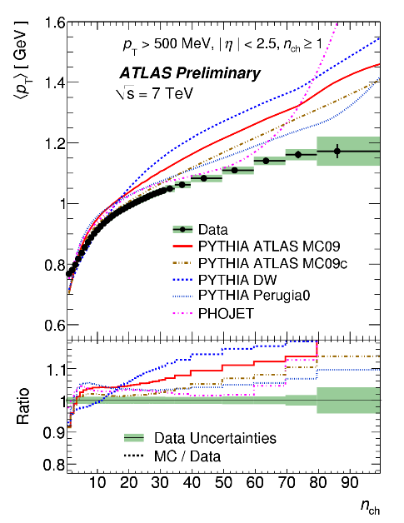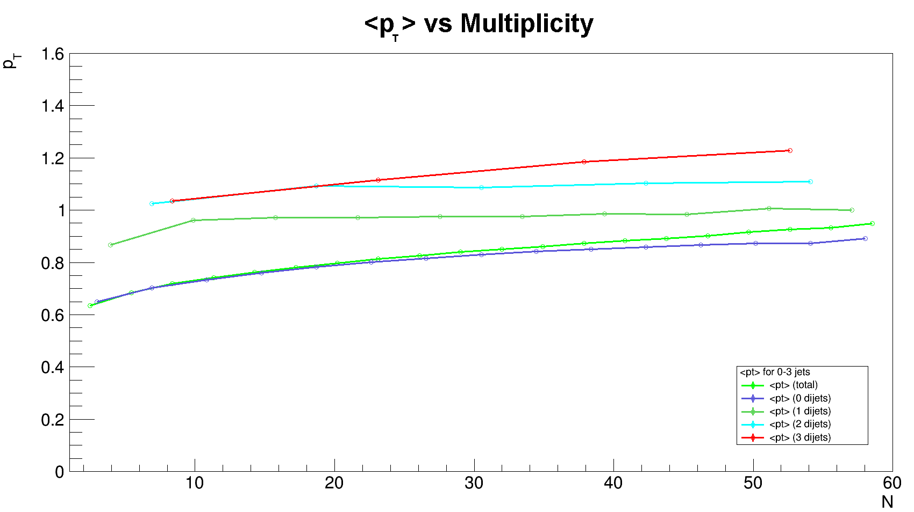

Figure 2 – Average Transverse Momentum/Multiplicity Correlation from Experimental Data

Figure 1 – Average Transverse Momentum/Multiplicity Correlation from ATLAS 2011

Using the above graphs as a sanity check throughout the process, and also served to confirm our suspicions that larger groups of particles had larger average momentum per particle, as one would expect from the jets resulting from the high energy collision.

**3.1 Computational Analysis**

The results for this project were attained via C++ macros utilizing the ROOT framework for file handling and graphing. As explained above, the simulations were carried out via the PYTHIA->FastJet chain of programs, resulting in a file with all the eligible particles sorted into di-jets of varying degree.

In the first pass of code the macro was written to load multiple simulation files, iterate through all events in each file, and finally aggregate all of that information into useable data. Unfortunately, with incredibly large numbers of events the aggregation of data resulted in numerical buffer overflows, rendering this process of calculation ineffective for the project.

With the second pass of code the macro was re-written to prevent the buffer overflow via a different means to calculate the average numbers of particles per event (the value which was overflowing), though this did require two subsequent passes on the data to fully calculate the values. Of note with this pass is the alteration of the pseudo-rapidity cuts, with the values set much wider than previously used before. In addition to this, no minimum velocity cut (${\hat{p}}_{T(min)}$, ptHatMin) was used.

Five million total events were supplied to the final analysis code, with a pseudo-rapidity cut of ±2.5 and a rapidity of ±10. No charge restrictions were placed as well.

**3.2** *D* **and Calculations**

To determine *D* , two main components are required: covariance of average total momentum and average number of particles per event, in addition to the variance of the number of particles per event multiplied by the average momentum per particle. Below is the numerical data collected from the second macro which was used (including only data which was included via cuts):

|  |  |  |  |  |  |  |  |  |  |
| --- | --- | --- | --- | --- | --- | --- | --- | --- | --- |
| Di-Jet Class | N | <N> | <N2> | Var(N) | <PT> | <pT> | <PTN> | Cov(PT, N) | *D* |
| TOTAL | 4968956 | 17.6888 | 512.706 | 199.812 | 17.5687 | 0.993212 | 528.767 | 217.997 | **0.0624514** |
| 0 | 4845932 | 17.1496 | 512.706 | 199.812 | 16.7981 | 0.979505 | 484.829 | 196.75 | **0.0537314** |
| 1 | 116956 | 37.9967 | 1755.23 | 311.487 | 46.3787 | 1.2206 | 2122.97 | 360.731 | **-0.0134855** |
| 2 | 5661 | 55.9251 | 3478.92 | 351.306 | 75.7423 | 1.35435 | 4667.41 | 431.511 | **-0.014158** |
| 3 | 377 | 69.8329 | 5258.66 | 382.028 | 102.338 | 1.46547 | 7628.4 | 481.852 | **-0.0159941** |

Of interest is the gradual increase of average momentum per particle as the di-jet class is increased, which is a result of the higher energies inherent in larger quantities of di-jets. In addition, the number of events for specific di-jet classes decreases as the di-jet class increases, as the higher-order di-jet classes become rarer as they increase.

Also of significant interest is the bizarre behavior of *D*  with increasing di-jet classes. As shown above, the average momentum per particle increases rapidly for increasing di-jet class. Subsequently, the variance and covariance are relatively close in magnitude, and as such any value for $<p_{T}>$ above 1.0 can result in a larger variance compared to the covariance. As such, it is observed that *D*  becomes negative when exclusively looking at higher-order di-jet classes. For these instances, it is implied that *D*  does not hold when looking at any values containing exclusively di-jet classes. Though, it does appear that *D*  behaves as expected when looking only at data without the separation of individual di-jet classes.

In a similar vein, looking at the data for the zero di-jet class shows a decrease in the values for *D* , which can be explained due to the lower jet contents inherent in the specification of zero di-jets. Particularly of importance is the fact that *D*  does indeed increase when the totals of jet content are added back into the zero di-jet data, providing some evidence that *D*  does increase with jet content and decrease in the absence of jet content.

Overall, we decided that calculations for *D*  could only be performed on total event classes when looking for the originally predicted behavior (larger values for higher orders of jets). This does not completely discount *D*  for singular jet-classes, though through the scope of this project it is unknown if there exists as true significance for these observables.

As a brief overview of the findings/considerations from this project:

* *D*  expected to increase with jet content present in collision
* Five million events at 7 TeV processed with η = ±2.5 and rapidity = ±10
* Average particle momentum as a function of multiplicity followed expected curves
* *D*  will decrease (into negatives) when jet content is separated into di-jet exclusive groupings
* More research will be needed to determine any significant information in relation to the jet-content exclusive *D*  results
  + Will test with multiple energy levels, higher number of simulations used

**4.1 Resources/Bibliography**

I would like to take a brief moment to thank everyone that made this research possible, including Dr. Sean Gavin, Dr. George Moschelli, and the whole Wayne State University Physics department for hosting the summer REU program which I participated in.

Resources Used:

* Charged-particle multiplicities in pp interactions measured with the ATLAS detector at the LHC - ATLAS Collaboration (Aad, G. et al.) New J.Phys. 13 (2011) 053033 arXiv:1012.5104 [hep-ex] CERN-PH-EP-2010-079
  + For Figure 11 (a) and general information