African American Studies at Wayne State University
Since 1989, the Department of African American Studies has provided students an opportunity to study, recognize and expand the global contributions and historical advancements of Black people, while adding to Wayne State University’s deep and rich history as an engine for educational success and social mobility for urban populations.
Faculty members within the department specialize in exploring and conveying the issues that, for years, have plagued Black communities and promoting the development of meaningful change in society, with a mission of creating more inclusive curricula for students and engaging in service with the Black community. The department’s recent hiring of three professors and researchers — specializing in global policy, engagement and organizing within Black communities — illustrates the importance and impact of building a strong faculty.
The department’s mission was recently strengthened by a $6 million grant from the Mellon Foundation to launch a cluster hire program that will recruit 30 new humanities faculty members and create the Detroit Center for Black Studies. The grant has solidified Wayne State as a leader in postsecondary diversity and representation, boasting the most diverse student body of any Michigan university.

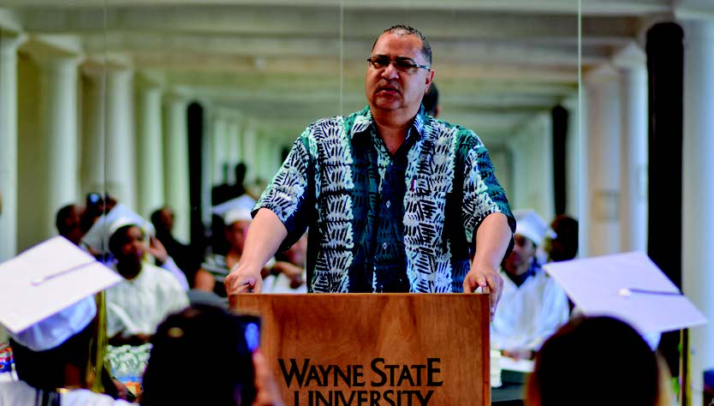
[“The new hires make Wayne State more diverse, inclusive and brilliant. These young scholars believe in community engagement and challenge us to take the global Black community seriously. With these two major improvements to diversity and equity at our university, we can ensure Detroit remains a major contributor to culture, art and literature. Once again, Wayne State is leading the way.” — Ollie Johnson, Ph.D., Chair, Department of African American Studies]
Donor support for initiatives in the Department of African American Studies will build on its increasing momentum, taking the department to even higher levels of achievement and reputation.

Department distinctions

Detroit Center for Black Studies
Wayne State is a leader in researching the African American and global Black experience. The new Detroit Center for Black Studies will serve as a dedicated research institute for the study of Black history, culture and politics, paralleling the outstanding contributions that Detroiters have made to the enrichment of the world and the struggle for racial justice and equity.
Support for the center will create programming and research opportunities that draw students, researchers and scholars who want to impact and advance Black studies in the unique cultural environment that is Detroit. The city will be their inspiration and classroom, offering a robust space to understand and explore the local and national Black experience.

Crockett-Lumumba Scholars
Currently a pilot program, Crockett-Lumumba Scholars (CLS) is a supportive learning community that will allow historically marginalized and underrepresented students in any of Wayne State’s undergraduate programs to take advantage of peer and faculty mentoring, financial aid coaching, scholarship-seeking, tutoring, college success seminars and social activities. Enrollment in CLS course sections is limited to 20 students to allow for personal mentorship between the instructor and students throughout the semester. The program is supported by the Office of Multicultural Student Engagement (OMSE), the Department of African American Studies, and the Warrior 360 student success program.
Investing in the CLS program will help students better understand themselves and their cultural inheritance while immersing in a community of peers, faculty and mentors who support the achievement of their personal, academic and professional goals. The program focuses on community building, mentorship, culturally relevant education, and a commitment to Black success and social justice on and off campus through a summer bridge program, dedicated learning community, yearly stipends for qualified program participants, and a study-abroad experience in the final year.

UBIN Read In (You Been Readin’)
UBIN Read In is a literary intervention to promote digital and information literacies throughout metro Detroit. The UBIN Read In program removes physical barriers set in place by traditional sites of teaching and learning, such as classrooms, libraries and bookstores. Creating access to a common text that people read generates organic and engineered conversations within the community with the potential to engage and refine skills.
Support for UBIN Read In will provide in-person and online workshops on five components of information literacy, including identifying, finding, evaluating, applying and acknowledging information. Support will also assist in distributing 10,000 copies of the book Crazy as Hell: The Best Little Guide to Black History within metro Detroit communities, helping participants enhance their literacy and communication skills and further their educational progress. The impacts of the program empower communities within metro Detroit with the tools to become self-advocates and effective cultural and informational consumers.

WSU Another Chance
The WSU Another Chance program, led by African American Studies Distinguished Service Professor Daphne Ntiri, is a declaration of the university’s strong commitment to outreach in neighboring communities for adults lacking basic literacy and educational skills, moving them along the pathway to success. It meets the educational needs of the disproportionately large numbers of Detroit residents without academic preparation to transition into post-secondary institutions or the world of work. These adult learners aim to complete high school or earn their general education degrees (GED), and students have access to occupational information and encouragement to pursue definitive goals and gain control of their lives. WSU Another Chance is currently supported by several grantors and donors, including the Michigan Department of Labor and Economic Opportunity, Community Foundation for Southeast Michigan and Dollar General.
Support for WSU Another Chance provides individualized learning opportunities, small-group instruction, peer study groups and one-on-one instruction that participants need to succeed throughout college and as part of the workforce. Program services include GED examination preparation, tutoring, college application assistance, community resource referrals, career development and a dedicated graduation ceremony for students each year.

Spotlighting AFS faculty and alumni
Distinguished Professor Melba Joyce Boyd is a prolific poet, scholar, filmmaker and editor who was named the 2023 Kresge Eminent Artist for her exceptional contributions to the growth and vibrancy of Detroit’s cultural and artistic landscape.
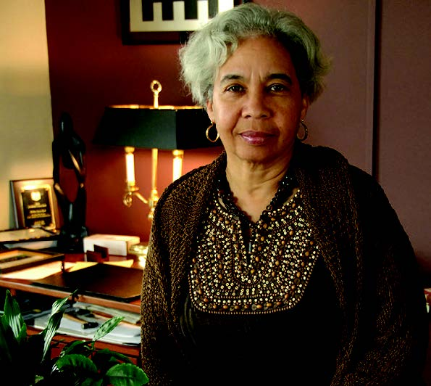
[“The one thing that’s great about this award is that you don’t apply for it. You’re getting real appreciation for your work from people who understand what it means to make work in Detroit. That’s something special. It’s a reminder and celebration of the culture we have here and the way that it continues.” — Melba Joyce Boyd, Ph.D., Distinguished Professor, Department of African American Studies]

Nakia-Renne Wallace ’21
An alumna of African American Studies and English at Wayne State and co-leader of the activist group Detroit Will Breathe. During her studies and at the pinnacle of the George Floyd protests, Nakia led peaceful demonstrations calling for the end of racial injustice and police brutality in Detroit and across the nation. A standout student in the classroom and in society, Nakia’s strength and determination to resist systemic racism have helped the Detroit community move closer to healing wounds that are years in the making.
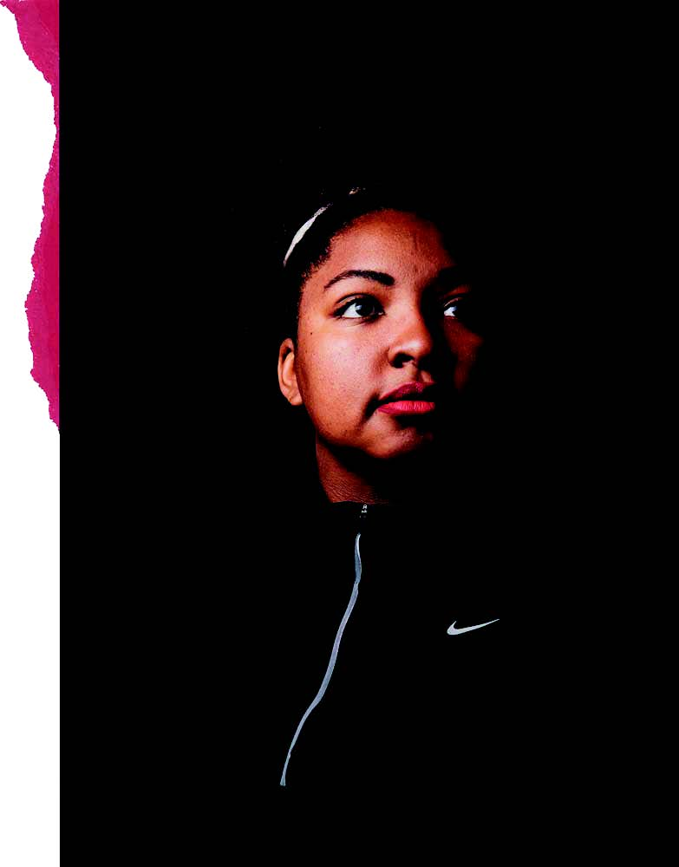
[“Detroit is the Blackest city in the nation, and it is a stronghold of Black strength. Every single time there is large social progress in the nation, Detroit has played a role. We’ve been taught by our ancestors to do this our entire lives. We won’t go silently.” — Nakia-Renne Wallace, Co-leader of Detroit Will Breathe]

Daphne Ntiri
Distinguished Service Professor Dr. Daphne W. Ntiri, a recent Hall of Fame laureate, has shown unwavering dedication to the WSU Another Chance program, resulting in several grants — including three from Dollar General — to support adult education opportunities. This grant funding helps make a college education attainable for communities that otherwise would not have access to such opportunities and resources. Dr. Ntiri is a 2014 recipient of the WSU Arthur L. Johnson Individual Community Leadership Award and the 2022 Hall of Fame honor at Cork University, Ireland.
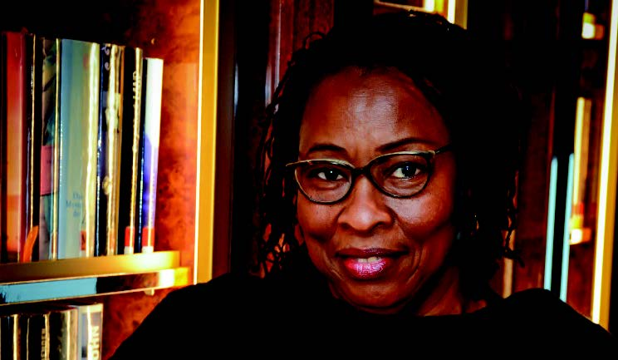
[“Students depend largely on smartphones and Chromebooks as their primary devices to access the internet. To keep pace with this evolving digital age, increased funding to ensure high-quality programmatic and instructional delivery for communities where Black and people of color live is necessary to promote greater racial equity and access to education.” — Daphne W. Ntiri, Ph.D., Distinguished Service Professor, Department of African American Studies]

Supporting our programs and mission
You can help further the university’s impact on racial equity and social justice by supporting Department of African American Studies programming and the Detroit Center for Black Studies. Your gift in support of our mission increases opportunities for our students, faculty and the community. With your investment, we’ll continue to offer an unparalleled academic experience, both in and out of the classroom, and expand our engagement with and support for Black and historically marginalized communities.

Give to the College of Liberal Arts and Sciences
giving.wayne.edu/donate/clas

A degree in African American Studies
clas.wayne.edu/afamstudies

Make a Difference
clas.wayne.edu/alumni/make-a-difference

[footer]
Jeremy Cybulski
Assistant director of development
College of Liberal Arts and Sciences
313-577-9081
Jeremy.cybulski@wayne.edu

