MARC

Maximizing Access to Research Careers

2021–2023

A look back at the progress of the first year of the MARC program at WSU and a look forward into the new 2022-2023 cohort and plans for the future.

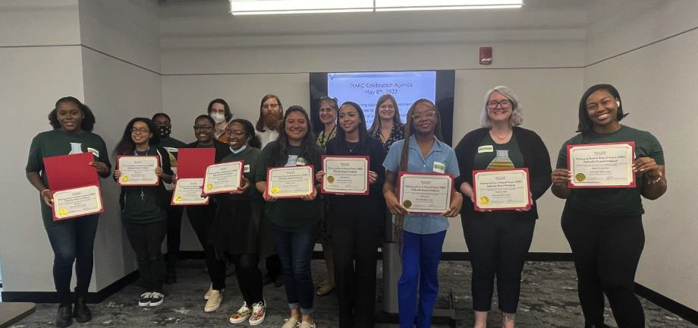

clas.wayne.edu/research/marc

Overview of MARC Program goals
The MARC program is designed to build a cohort of research-oriented students from groups traditionally underrepresented in STEM fields: African American, Hispanic American, Native American, Native of Pacific Islands, disabled, or disadvantaged backgrounds.

Additionally, the program specifically supports students interested in pursuing careers as biomedical scientists and plan to, or are willing to consider, Ph.D. programs in the biomedical sciences after graduation.

Summary of year one
Making a good first impression counts!

Initial Funding and Training End-of-the-year Celebration!
The MARC program at WSU secured funding in the summer of 2021, and the inaugural MARC cohort was accepted and began their training in August of 2021. Additionally, MARC mentors were selected and received mentor training and MARC contracts outlining their commitment to the program and the success of the MARC scholars.

The inaugural cohort consisted of 12 students: five senior MARC scholars, five junior MARC scholars, and two pre-MARC scholars. Each scholar was matched to a research lab, began research, and participated in the weekly learning communities specifically designed to foster their scientific careers throughout the fall and winter semesters. Topics ranged from ethics to graduate-school applications Different MARC mentors participated weekly in the lessons.

End-of-the-year Celebration!
To celebrate the success of the first year of the MARC program, an End-of-the-year Celebration was held on May 6th, 2022 in the SILC building at WSU. The celebration started with an introduction to the MARC program administration and a brief overview of the MARC program for parents and guests. The celebration included refreshments and cake to honor the achievements of all of the MARC and pre-MARC scholars, a poster show featuring the research of the current MARC and pre-MARC scholars, a presentation of certificates to the inaugural class, and an opportunity for the new MARC and pre-MARC scholars to interact within the MARC program. A highlight of the celebration was the opportunity for the family and support people for the MARC scholars to interact with the MARC scholars and mentors during the poster show and learn about the research of the MARC scholars throughout the last year.

The graduating MARC Scholars
All five senior MARC scholars successfully completed their desired undergraduate degrees. We wish them the best of luck as they move forward in their goals to receive Ph.D.s in the biomedical sciences!

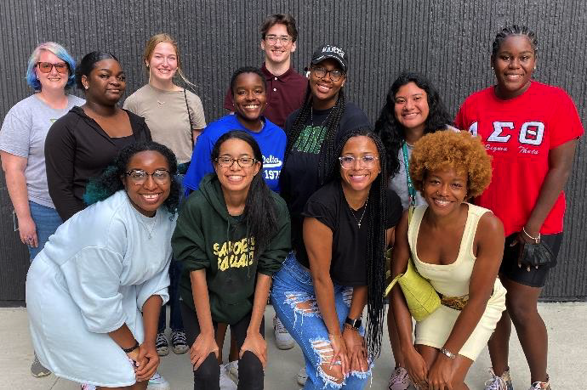
2021–2022 inaugural class, August 2021

Nailah Bowman
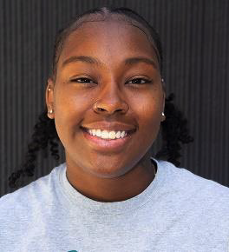
Senior MARC Scholar for 2021–2022 MARC
Mentor: Dr. Lara Jones Psychology
B.S. in Psychology, Minor in Gender and Women’s studies; Honors in May of 2022. Accepted a research technician position at University of Michigan, Ann Arbor researching bipolar disorder.

Sydni Elebra
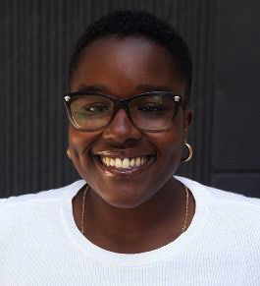
Senior MARC Scholar for 2021–2022 MARC
Mentor: Dr. Charlie Fehl Chemistry
B.S. in Chemistry, Minor in Biochemistry and Chemical Biology in May of 2022.

James C. French Endowed Undergraduate Chemistry Scholarship awardee, ReBUILD Detroit Scholar, WSU Good Scholarship Awardee Continuing her studies in chemistry at Emory University Ph.D. program Fall of 2022; Centennial Scholar, Laney fellow, Women in Natural Sciences fellow, IMSD fellow, Quayle New Student Awardee.

Kailyn K. Fields
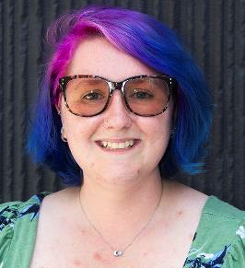
Senior MARC Scholar for 2021–2022 MARC
Mentor: Dr. Matthew Allen Chemistry
B.S. in Biomedical Physics, concentration: Biophysics; B.S. in Physics, concentration: Engineering and Applied Physics in May of 2022 Summer 2022 Research Assistantship with Army ERDC in Vicksburg, Mississippi. Continuing her studies in chemistry at Wayne State University Ph.D. program Fall of 2022; Chair’s Award of Excellence.

Alexis Taylor
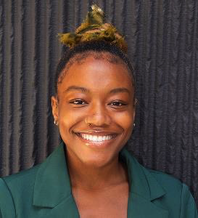
Senior MARC Scholar for 2021–2022
MARC Mentor: Dr. Chris Trentacosta Psychology
B.S. in Psychology and Public Health in May of 2022. Accepted a position as lab manager in Dr. Trentacosta's Detroit Youth Across Development lab.

Skye Taylor
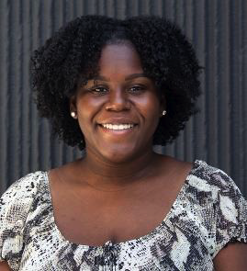
Senior MARC Scholar for 2021–2022
MARC Mentor: Dr. Emily Grekin Psychology
B.S. in Psychology, Minor in Public Health; Departmental Honors in May of 2022
Selected as a speaker at CLAS commencement. Continuing her studies in psychology at Michigan State University Ph.D. program fall of 2022.

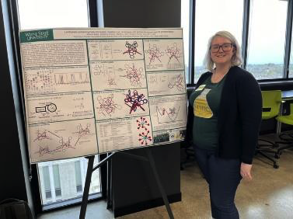
Kailyn K. Fields presenting her poster at the end-of-the-year celebration.

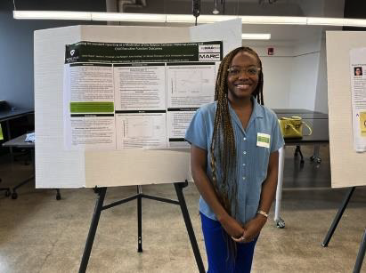
Alexis Taylor presenting her poster at the end-of-the-year celebration.

Year 2

2022–2023 MARC and pre-MARC Cohort

Applications for the MARC and pre-MARC 2022–2023 program were opened in January of 2022. The second cohort of MARC scholars consists of 10 scholars (6 seniors and 4 juniors) and 5 pre-MARC scholars. Scholars started the program and matched with mentors in May of 2022 (see table below).

Student Name | Year | Major | MARC Mentor | MARC Mentor Field
Melissa Torres | SMARC | Biomedical engineering | Howard Matthew | COE Chem engineering
Elliot F Widd | SMARC | Biomedical engineering | Carolyn Harris | COE Chem engineering
Milan Rogan | SMARC | Biology | Victoria Meller | CLAS Bio Sci
Autumn Lauren Hill | SMARC | Biology/Neuroscience | Sokol Todi | SOM Pharmacology
Kennedy Watson | SMARC | Neuroscience | Stephan Patrick | SOM Oncology
Lauryn Williams | SMARC | Chemistry | Tamara Hendrickson | CLAS Chemistry
Jodi Protasiewicz | JMARC | Biology | RJ Wessells | SOM Physiology
Rei Fejzulla | JMARC | Biochemistry and Chem Bio | Jennifer Stockdill | CLAS Chemistry
Thais Pichardo | JMARC | Nutrition and Food Science | Larry Matherly | SOM Oncology
Anna Avant | JMARC | Environmental Science | Yifan Zhang | CLAS Nutrition and Food Science
Skyler Ways | Pre-MARC | Neuroscience | Chris Trentacosta | CLAS Psychology
Nelson Glory-Ejoyokah | Pre-MARC | Neuroscience | Chris Trentacosta | CLAS Psychology
Katelynn Haygood | Pre-MARC | Environmental Sciences | Shirley Papuga | CLAS Environmental Science and Geology
Sarah Haque | Pre-MARC | Neuroscience | Undecided
Jayy Rimbert | Pre-MARC | Psychology | Undecided

Summer 2022 MARC
During the summer, MARC scholars are required to participate in research 37.5 hours a week and attend MARC learning communities biweekly. A large focus for the learning communities during the summer is graduate school and fellowship applications to best prepare the senior students for the application process in the fall.

Plans for the fall 2022 and winter 2023 semesters
We will have weekly learning communities during the Fall and Winter semesters for the scholars, with expected participation from the MARC mentors. Additionally, Senior MARC scholars are expected to apply to graduate school in the Fall semester.
For the MARC mentors: There will be required mentor training in November of 2022 for all MARC mentors wishing to continue with the MARC program.

Thank you!
Thank you to all MARC mentors, administration, and support staff for your continued support of the MARC program as we progress into the second year of the program. We look forward to many more successful years as we help guide these outstanding students towards careers in the biomedical sciences.

Sincerely,

Brooke Corbin - MARC Program Facilitator
Matthew Allen - MARC Program Co-Director
Lori Pile - MARC Program Co-Director

